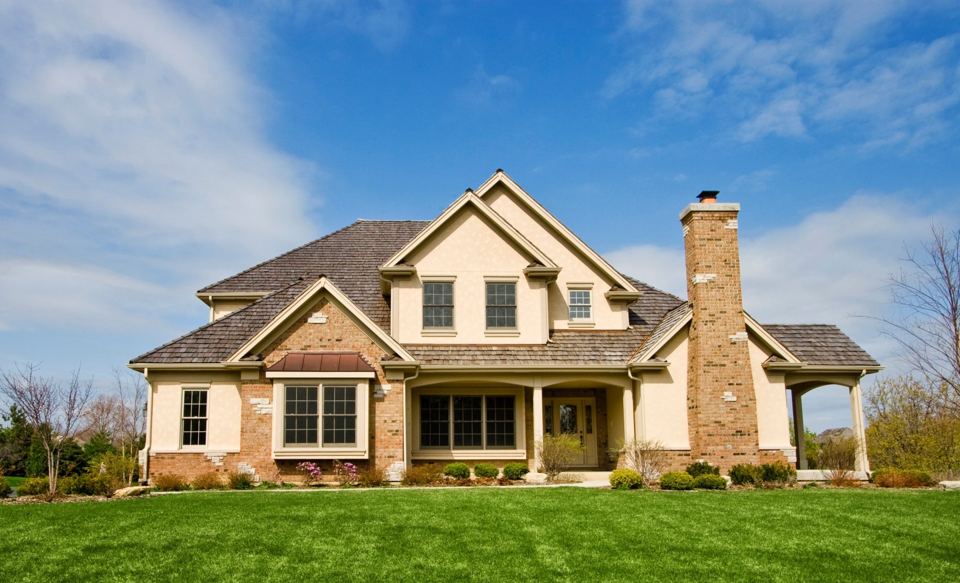

DEKALB COUNTY
FIRST-TIME HOMEBUYER
DOWN PAYMENT ASSISTANCE PROGRAM
Eligibility
2017 Annual Income Limits
Household of 1------------$39,050
Household of 2------------$44,600
Household of 3------------$50,200
Household of 4------------$55,750
Household of 5------------$60,250
Household of 6------------$64,700
Household of 7------------$69,150
Household of 8+ ---------$73,600

How does your credit history affect eligibility?
Applicants must be credit-worthy as determined by one of the program’s Participating Lenders. Any judgments, garnishments, bankruptcies, collections or too many debts may affect your ability to qualify for a loan.

How much must the buyer contribute?
Buyers must contribute a minimum of one percent (1%) of the total purchase price.

How can DeKalb assist you?
Eligible applicants with credit scores of 620 or above can receive up to $8,000 toward their down payment and closing cost (amount needed to close only).

Eligible applicants with credit scores less than 620 can receive up to $5,000 to assist with down payment and closing cost (amount needed to close only).

Who is eligible?
First-time homebuyers that have not owned a home during the last three years are eligible. Successful applicants must meet maximum income guidelines and be credit-worthy.

What about the home?
Single-family detached home in DeKalb County, outside the city limits of Atlanta. Homes must meet all DeKalb County codes at the time of purchase. No Condos or Townhomes. The maximum purchase price of the home cannot exceed $160,000.

Register for Counseling
Applicants must first attend a workshop with one of the participating HUD–approved housing counseling agencies listed on the reverse side. Enroll Today!

How long is the process?
The program requires 60 days from contract execution for each transaction, or 30 days from the submission of the complete DPA application package.

IMPORTANT NOTICE
Housing counseling with an HUD-approved housing counseling agency is the “front door” to this program. If you have an executed sales contract approval at the time of registration, the Program requires a minimum of 60 days to complete counseling and process each DPA applications package submitted for approval.

If the closing date is less than 30 days from submission, then a 30 day contract extension is required to allow for application processing and HUD eligibility certification.

GET REAL ANSWERS TO YOUR
HOMEBUYING QUESTIONS
GET STARTED TODAY

HUD- Approved Housing Counseling Agencies (2017-2018)

D&E Group, Inc. Green Forest CDC
4532 Jonesboro Road, 2nd Floor, 3299 Rainbow Dr., Decatur, GA 30034
Forest Park, GA 30297 Decatur, GA 30034
770-961-6900 - Office 770-961-8900 Fax 404-486-5768-Office
Web: www.depower.org Web: www.gfcdc.org
E-mail: jhope@depower.org Email: xavier.edwards@gfcdc.org

Morningstar Urban Development, Inc.
2501 Lantrac Court, Decatur, GA 30035
770-492-4037– Office
678-318-3676-Voicemail
Email: morningstarinc33@gmail.com

Resources for Residents and Communities
100 Flat Shoals Ave., S.E. Atlanta, GA 30316
404-525-4130 ext. 28—Office
Web: www.rrc-atl.org
Email: hoc@rrc-atl.org

The Center for Pan Asian Community Services
3510 Shallowford Rd. NE, Chamblee, GA 30341
770-936-0969 - Office
Web: www.cpacs.org
Email: andy.yoon@cpacs.org/ stephen.lee@cpacs.org

Urban League of Greater Atlanta
Peachtree Center - International Tower
229 Peachtree Street NE, Suite 300, Atlanta, GA 30303
404 659-1150- Office
Web: www.ulgatl.org
Email: info@ulgatl.org

Those who complete the workshop will receive a certificate of completion. The certificate is valid for one year. Following workshop completion, prospective homebuyers will also be required to meet one-on-one with a certified housing counselor for further for homeownership preparation. Workshop times and locations may vary by agency. Call today to enroll in a class that fits your schedule. (Please note: Some agencies may charge a fee for the workshop).
Topics covered in the workshop include:
- How to obtain a mortgage | - Budgeting and Credit
- Understanding your FICO score | - Types of financing available
- Money for down payment | - Evaluating your ability to afford a home
- Planning for homeownership responsibilities | - Avoiding foreclosure
This program is administered by the DeKalb County Department of Human and Community Development Single Family Housing Programs. The program has additional restrictions and eligibility requirement. If you have additional questions about the program after contacting the HUD Approved Housing Counseling Agency, call (404) 371-2727.
Revised 06/26/2017

